About RF-DETR model:

--------------------------- <https://github.com/roboflow/rf-detr> --------------------------------

RF-DETR is a real-time, transformer-based object detection model architecture developed by Roboflow and released under the Apache 2.0 license.

RF-DETR is the first real-time model to exceed 60 AP on the [Microsoft COCO benchmark](https://cocodataset.org/#home) alongside competitive performance at base sizes. It also achieves state-of-the-art performance on [RF100-VL](https://github.com/roboflow/rf100-vl), an object detection benchmark that measures model domain adaptability to real world problems. RF-DETR is fastest and most accurate for its size when compared current real-time objection models.

RF-DETR is small enough to run on the edge using [Inference](https://github.com/roboflow/inference), making it an ideal model for deployments that need both strong accuracy and real-time performance.

* 2025/07/23: We release three new checkpoints for RF-DETR: Nano, Small, and Medium.
  + RF-DETR Base is now deprecated. We recommend using RF-DETR Medium which offers subtantially better accuracy at comparable latency.

Please ensure inputs use RGB channel order.

If you don't plan to modify the image or batch size dynamically at runtime, you can also use .optimize_for_inference() to get up to 2x end-to-end speedup, depending on platform.

Our work is built upon [LW-DETR](https://arxiv.org/pdf/2406.03459), [DINOv2](https://arxiv.org/pdf/2304.07193), and [Deformable DETR](https://arxiv.org/pdf/2010.04159). Thanks to their authors for their excellent work!

------------- LW-DETR: A Transformer Replacement to YOLO for Real-Time Detection ---------

Abstract: In this paper, we present a light-weight detection trans former, LW-DETR, which outperforms YOLOs for real-time object de tection. The architecture is a simple stack of a ViT encoder, a projector, and a shallow DETR decoder.

ViT for object detection. Vision Transformer (ViT)

DETR and its variants. Detection Transformer (DETR) is an end-to-end de tection method, with removing the necessity of many hand-crafted components, such as anchor generation [51] and non-maximum suppression (NMS)

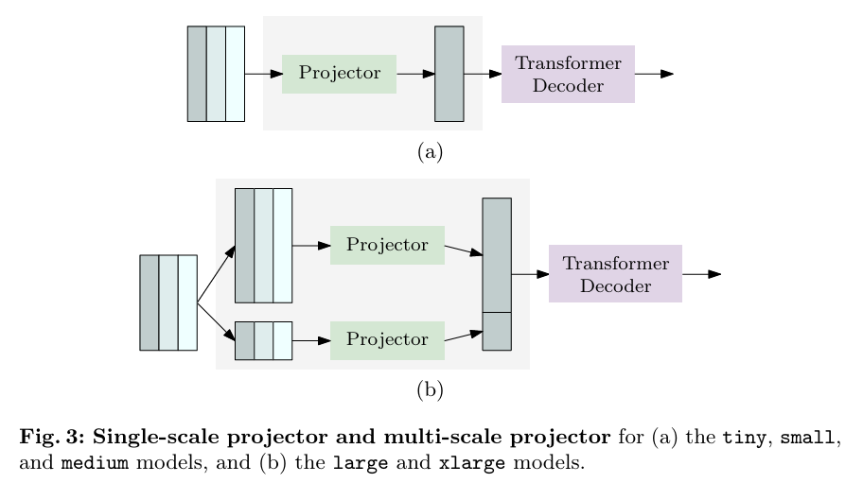

NMS post-processing. The DETR method is an end-to-end algorithm that does not need the NMS post-processing procedure. In contrast, existing real time detectors, such as YOLO-NAS [1], YOLOv8 [29], and RTMDet [46], needs NMS [24] post-processing. The NMS procedure takes extra time.

Conclusion This paper shows that detection transformers achieve competitive and even supe rior results over existing real-time detectors. Our method is simple and efficient. The success stems from multi-level feature aggregation and training-effective and inference-efficient techniques. We hope our experience can provide insights for building real-time models with transformers in vision tasks.

--------------- DINOv2: Learning Robust Visual Features without Supervision --------------------

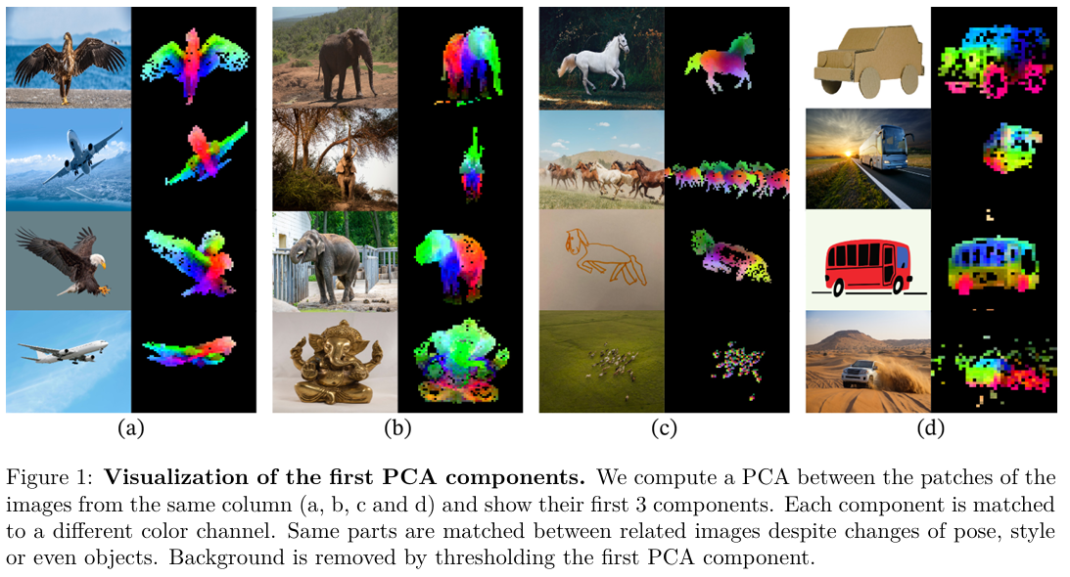



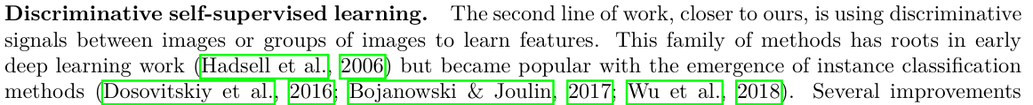

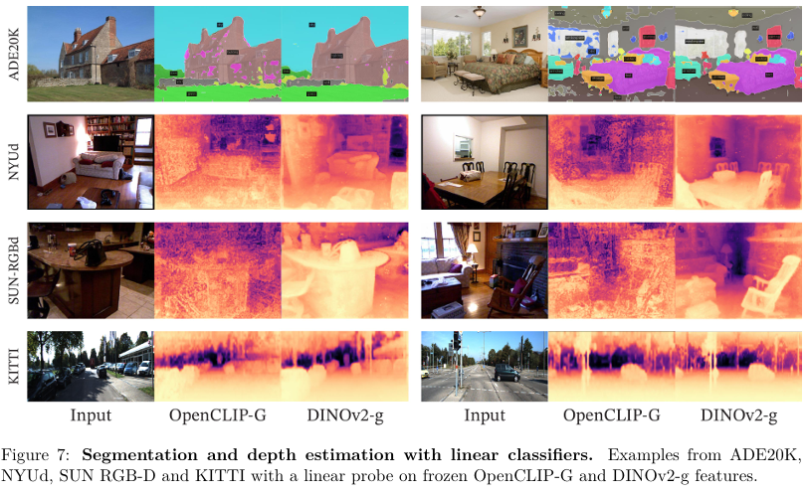

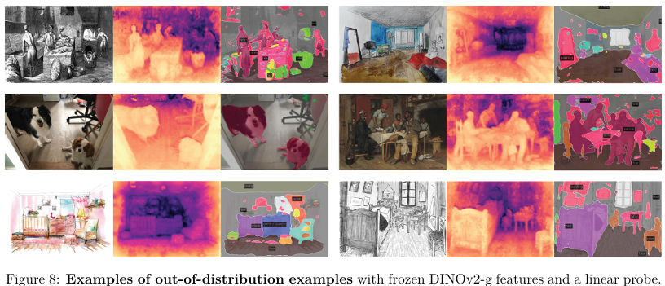

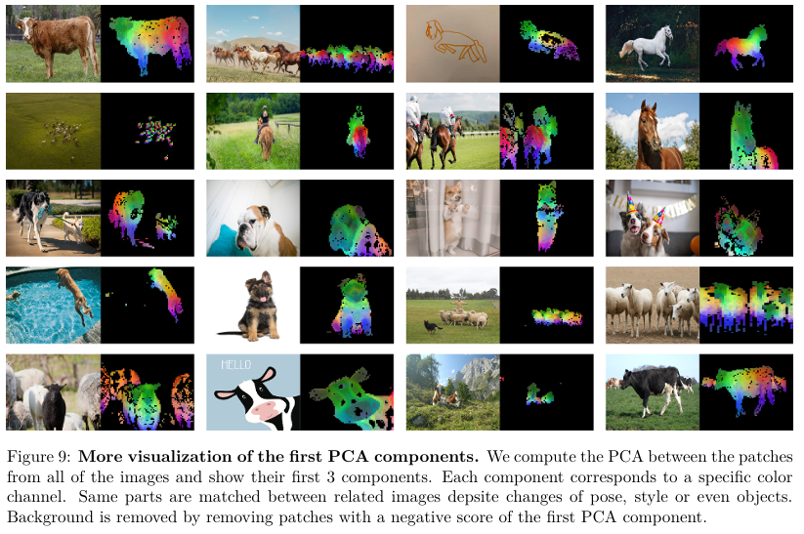

-------DEFORMABLE DETR: DEFORMABLE TRANSFORMERS FOR END-TO-END OBJECT DETECTION ---------------

DETR has been recently proposed to eliminate the need for many hand-designed components in object detection while demonstrating good performance. However, it suffers from slow convergence and limited feature spatial resolution, due to the limitation of Transformer attention modules in processing image feature maps. To mitigate these issues, we proposed Deformable DETR, whose attention modules only attend to a small set of key sampling points around a reference. Deformable DETR can achieve better performance than DETR (especially on small objects) with 10 less training epochs.

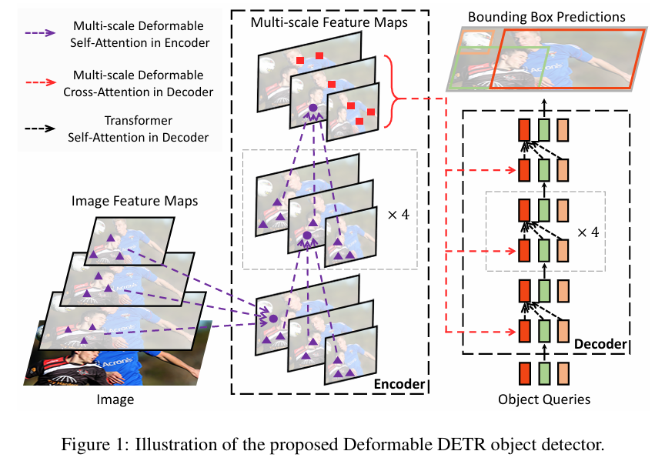

Multi-Head Attention in Transformers. Transformers (Vaswani et al., 2017) are of a network architecture based on attention mechanisms for machine translation. Given a query element (e.g., a target word in the output sentence) and a set of key elements (e.g., source words in the input sentence), the multi-head attention module adaptively aggregates the key contents according to the attention weights that measure the compatibility of query-key pairs.

DETRis an attractive design for object detection, which removes the need for many hand-designed components. However, it also has its own issues. These issues can be mainly attributed to the deficits of Transformer attention in handling image feature maps as key elements:

(1) DETR has relatively low performance in detecting small objects. Modern object detectors use high-resolution feature maps to better detect small objects. However, high-resolution feature maps would lead to an unacceptable complexity for the self-attention module in the Transformer encoder of DETR, which has a quadratic complexity with the spatial size of input feature maps.

(2) Compared with modern object detectors, DETR requires many more training epochs to converge. This is mainly because the attention modules processing image features are difficult to train. For example, at initialization, the cross-attention modules are almost of average attention on the whole feature maps. While, at the end of the training, the attention maps are learned to be very sparse, focusing only on the object extremities. It seems that DETR requires a long training schedule to learn such significant changes in the attention maps.

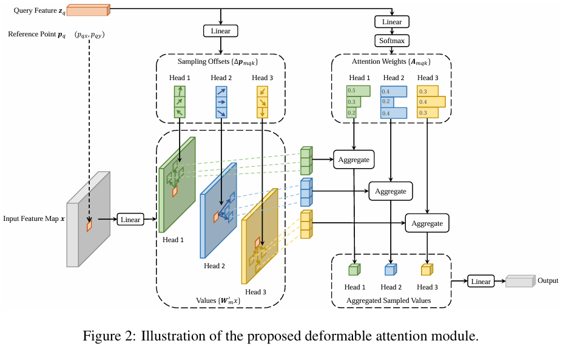

mapsisthat it would look overall possible spatial locations. To address this, we present a deformable attention module. Inspired by deformable convolution (Dai et al., 2017; Zhu et al., 2019b), the deformable attention module only attends to a small set of key sampling points around a reference point, regardless of the spatial size of the feature maps, as shown in Fig. 2. By assigning only a small fixed number of keys for each query, the issues of convergence and feature spatial resolution can be mitigated.

Multi-scale Deformable Attention Module. Most modern object detection frameworks benefit from multi-scale feature maps (Liu et al., 2020). Our proposed deformable attention module can be naturally extended for multi-scale feature maps.

Deformable Transformer Encoder. We replace the Transformer attention modules processing feature maps in DETR with the proposed multi-scale deformable attention module. Both the input and output of the encoder are of multi-scale feature maps with the same resolutions.

Deformable Transformer Decoder. There are cross-attention and self-attention modules in the decoder. The query elements for both types of attention modules are of object queries. In the cross attention modules, object queries extract features from the feature maps, where the key elements are of the output feature maps from the encoder. In the self-attention modules, object queries interact with each other, where the key elements are of the object queries. Since our proposed deformable attention module is designed for processing convolutional feature maps as key elements, we only replace each cross-attention module to be the multi-scale deformable attention module, while leaving the self-attention modules unchanged.

Because the multi-scale deformable attention module extracts image features around the reference point, we let the detection head predict the bounding box as relative offsets w.r.t. the reference point to further reduce the optimization difficulty.

By replacing Transformer attention modules with deformable attention modules in DETR, we es tablish an efficient and fast converging detection system, dubbed as Deformable DETR (see Fig. 1).

**ADDITIONAL IMPROVEMENTS AND VARIANTS FOR DEFORMABLE DETR**

Iterative Bounding Box Refinement. This is inspired by the iterative refinement developed in optical flow estimation (Teed & Deng, 2020). We establish a simple and effective iterative bounding box refinement mechanism to improve detection performance. Here, each decoder layer refines the bounding boxes based on the predictions from the previous layer. Two-Stage Deformable DETR. In the original DETR, object queries in the decoder are irrelevant to the current image. Inspired by two-stage object detectors, we explore a variant of Deformable DETRfor generating region proposals as the first stage. The generated region proposals will be fed into the decoder as object queries for further refinement, forming a two-stage Deformable DETR.

As shown in Table 1, compared with Faster R-CNN + FPN, DETR requires many more training epochs to converge, and delivers lower performance at detecting small objects. Compared with DETR, Deformable DETR achieves better performance (especially on small objects) with 10 less training epochs. Detailed convergence curves are shown in Fig. 3. With the aid of iterative bounding box refinement and two-stage paradigm, our method can further improve the detection accuracy.

Our proposed Deformable DETR has on par FLOPs with Faster R-CNN + FPN and DETR-DC5. But the runtime speed is much faster (1.6 ) than DETR-DC5, and is just 25% slower than Faster R-CNN+FPN.Thespeedissue of DETR-DC5 is mainly due to the large amount of memory access in Transformer attention. Our proposed deformable attention can mitigate this issue, at the cost of unordered memory access. Thus, it is still slightly slower than traditional convolution.

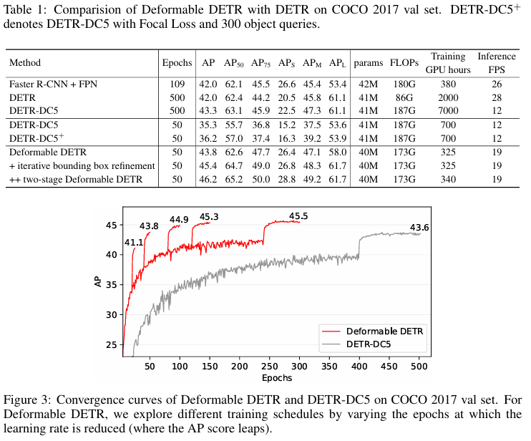

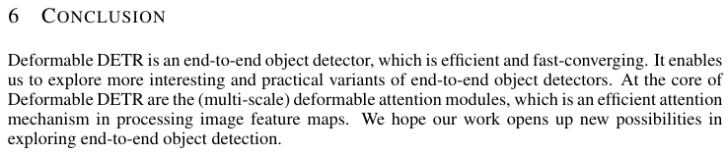

------- Semi-automatic Image Processing Algorithm for Cell Counting in Neubauer Chambers------

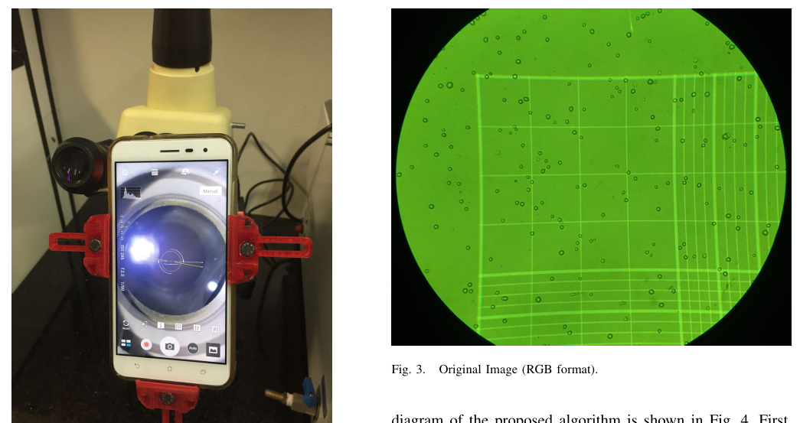

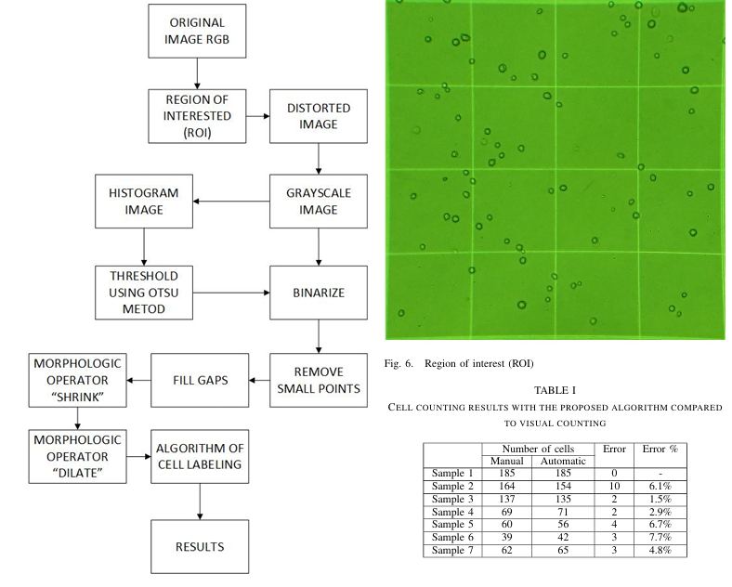

--------Optimised RFO tuned RF DETR model for precision urine microscopy for renal and systemic disease diagnosis------

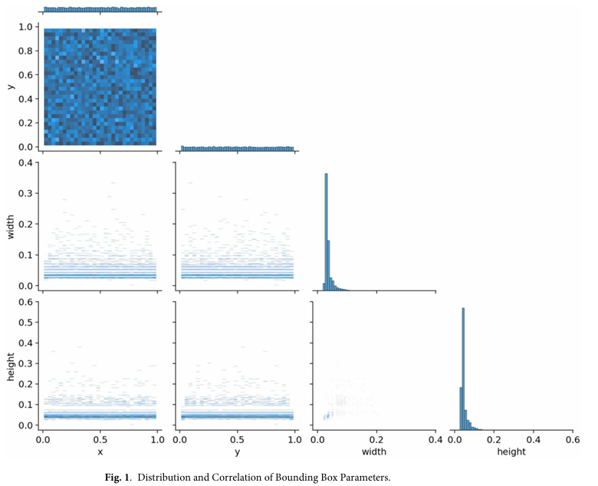

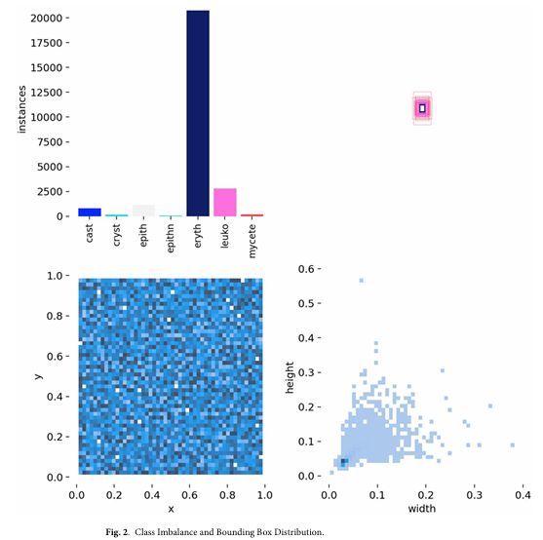

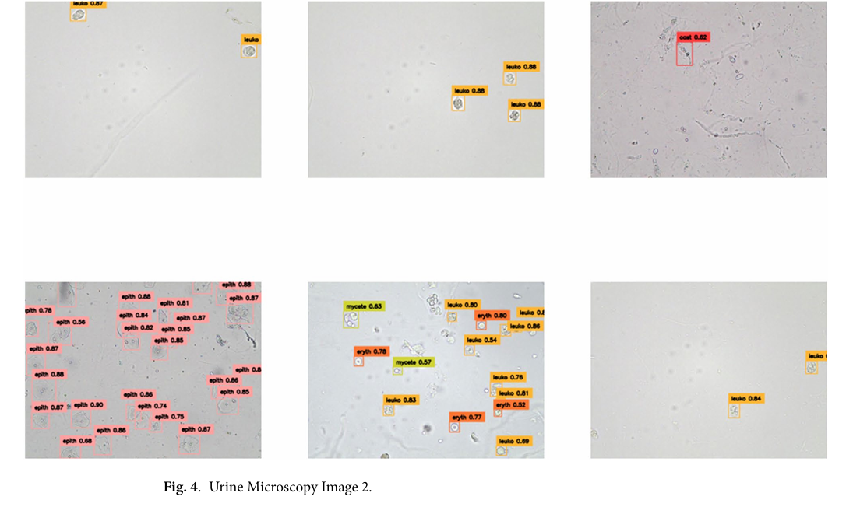

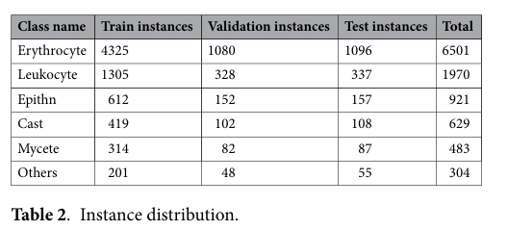

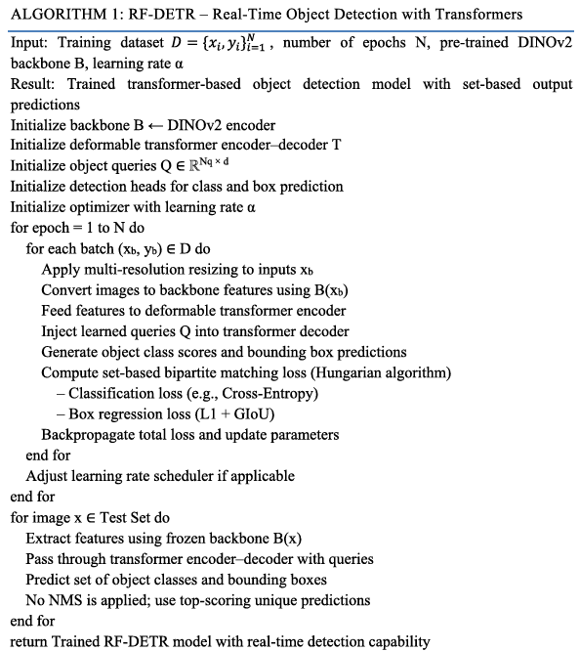

RF-DETR demonstrates improved convergence, detection accuracy, and robustness compared to the baseline DETR and other object detectors. These claims are supported by our experimental evaluations, where RF-DETR achieved higher mAP and IoU scores across multiple object classes. Similar trends have been observed in recent works using enhanced or tuned DETR variants (Li et al., 2022; Chen et al., 2022), further supporting our findings.

Additionally, RF-DETR’s transformer architecture demands careful balancing of computational efficiency and detection accuracy, especially when deployed in real-time or resource-constrained environments. RFO can op timize multi-objective functions—such as minimizing validation loss while maximizing mAP or FPS—thereby identifying hyperparameter sets that best meet deployment requirements. Its population-based approach also makes it suitable for parallelization, reducing overall tuning time. By using RFO, developers can automate the tuning process to systematically enhance RF-DETR’s performance across different domains, datasets, and hardware settings, ensuring the model is both accurate and efficient in practical applications.

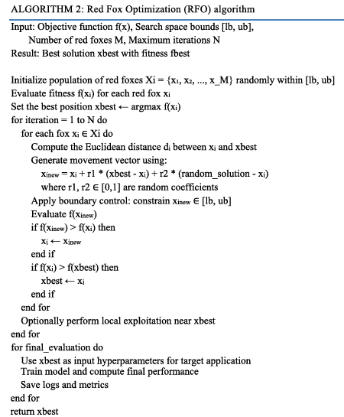

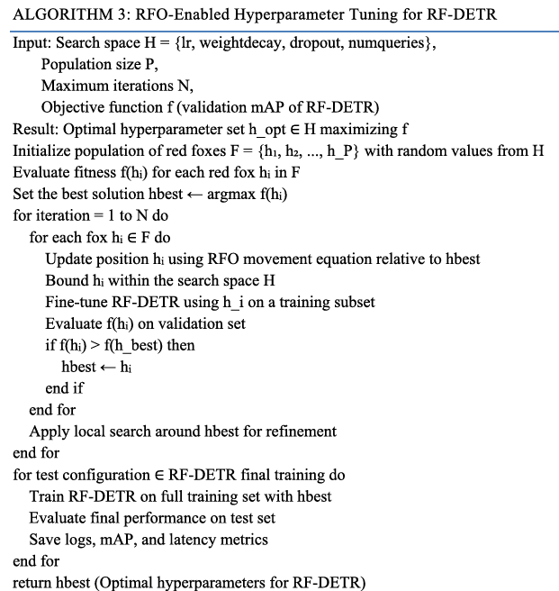

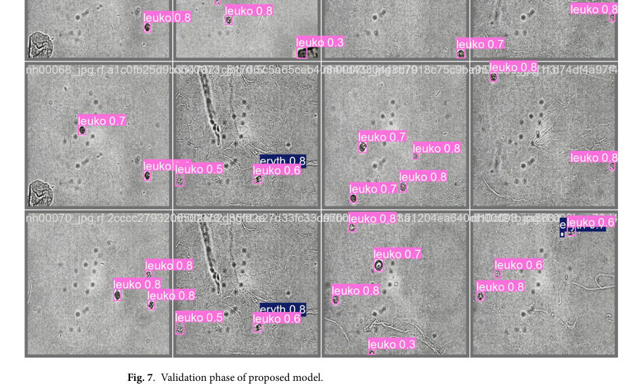

Figure 8 shows how recall (the ability to detect all true positives) varies with increasing confidence thresholds for different urine sediment classes.

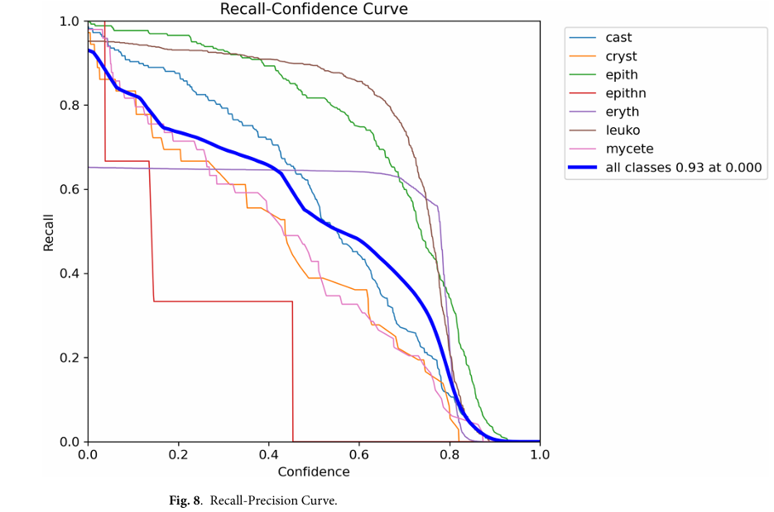

Figure 9 shows how the precision (correct positive predictions) changes with increasing confidence thresholds for each urine sediment class.

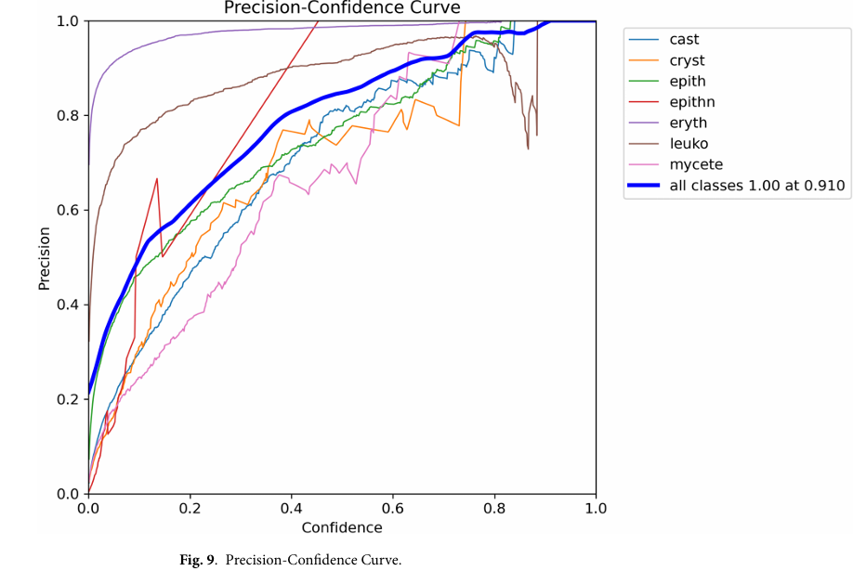

Figure 10 illustrates how the F1-score (a balance of precision and recall) varies with different confidence thresholds for each urine sediment class.

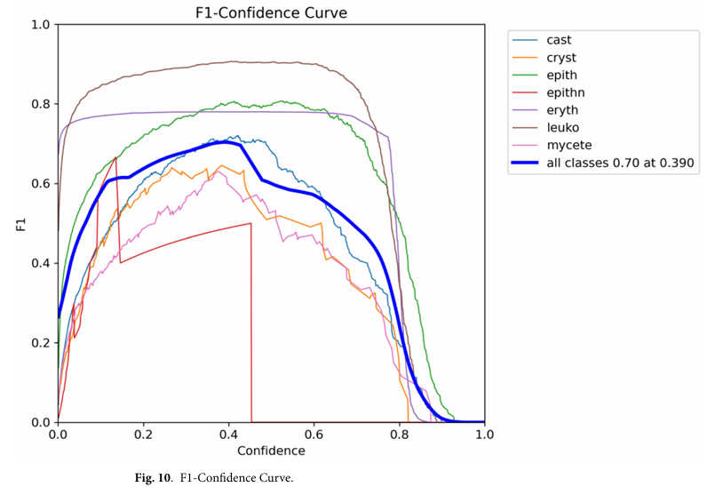

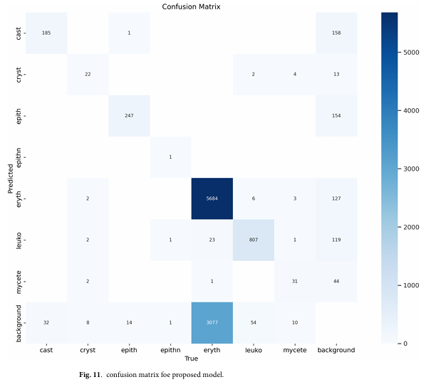

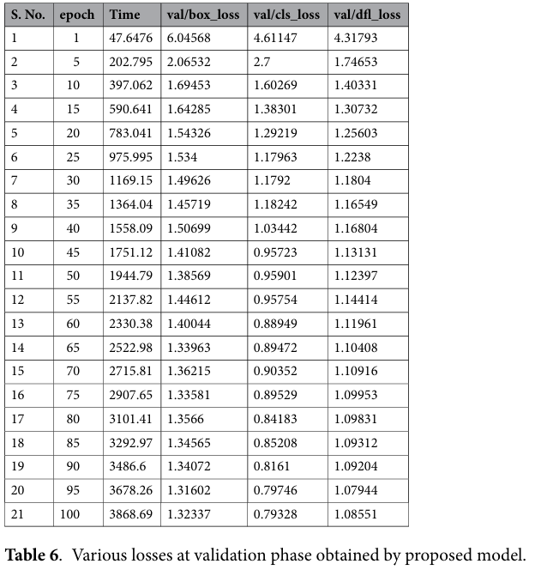

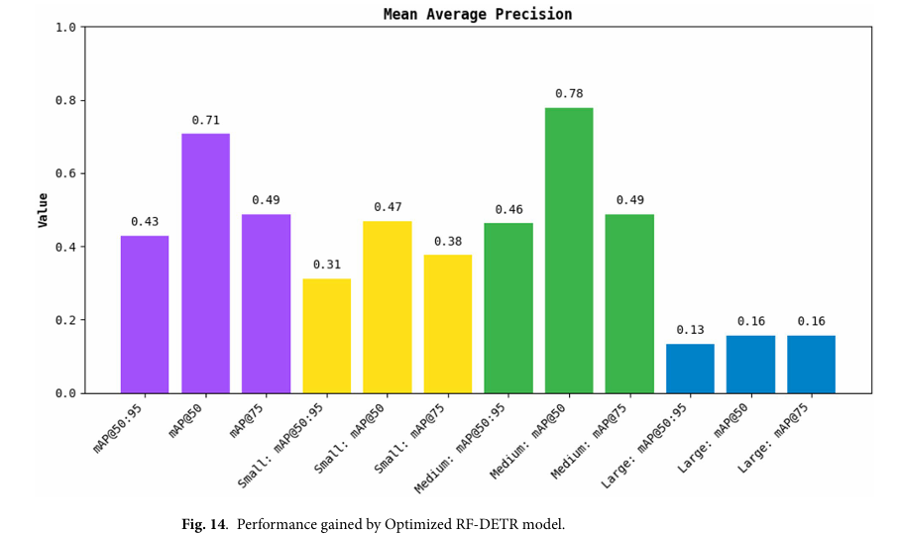

--------- Automatic Object Counting In Neubauer Chambers-------

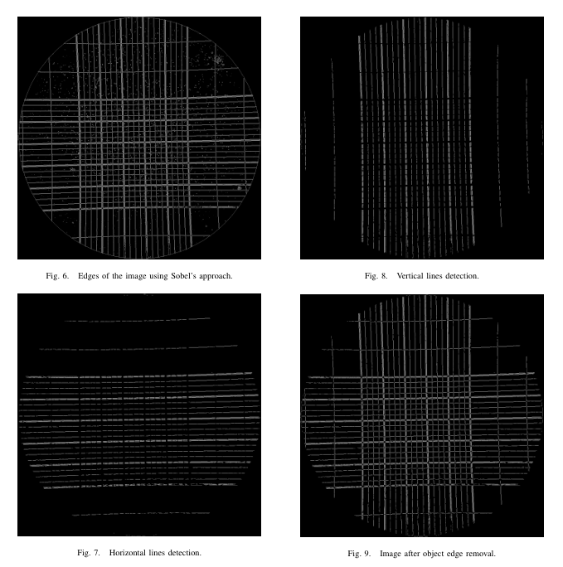

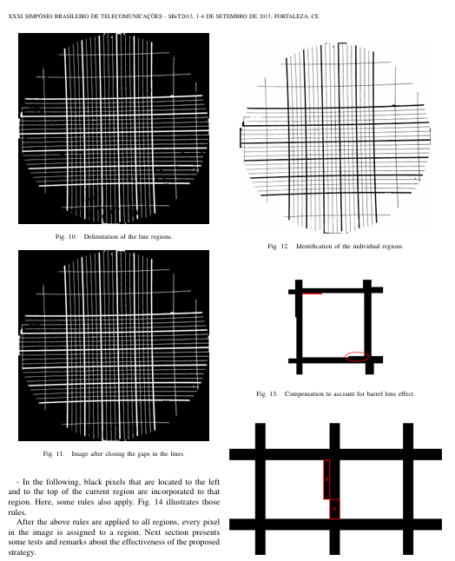

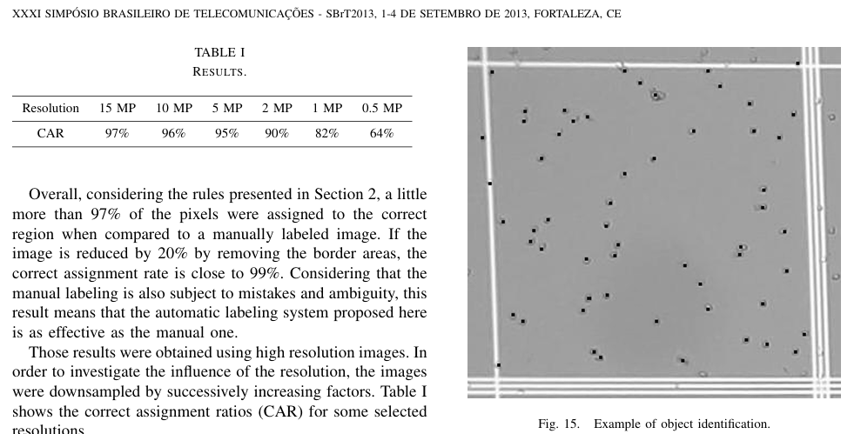

------- Automatic Cell Counting With YOLOv5: A Fluorescence Microscopy Approach---------

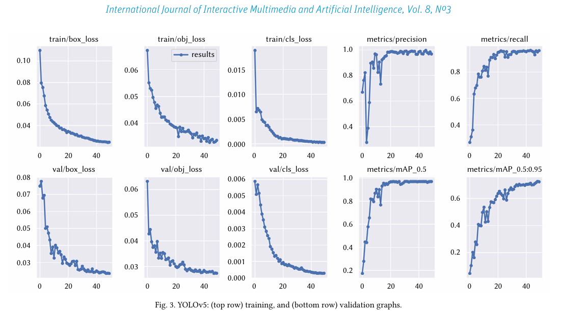

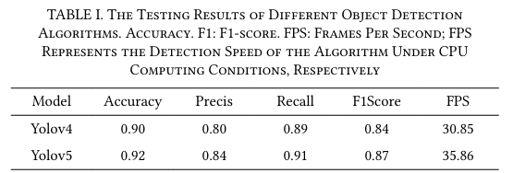

-------------- RF-DETR Object Detection vs YOLOv12 : A Study of Transformer-based and CNN-based Architectures for Single-Class and Multi-Class Greenfruit Detection in Complex Orchard Environments Under Label Ambiguity-------------------------------------------

